Aim : To perform screenshot handle in webdriver

Code :

package seleniumscripts;  
import java.io.File;  
import java.io.IOException;  
import org.apache.commons.io.FileUtils;  
import org.openqa.selenium.OutputType;  
import org.openqa.selenium.TakesScreenshot;  
import org.openqa.selenium.WebDriver;  
import org.openqa.selenium.chrome.ChromeDriver;  
public class ScreenShots {  
  public static void main(String[] args) throws InterruptedException, IOException {  
     WebDriver driver = new ChromeDriver();        
      driver.manage().window().maximize();        
      driver.get("https://opera.com/download");        
      Thread.sleep(1000);  
      File srcFile = ((TakesScreenshot)driver).getScreenshotAs(OutputType.FILE);  
        File destFile = new File("./Screenshots/opera.png");  
      FileUtils.copyFile(srcFile, destFile);        
  }  
  
}

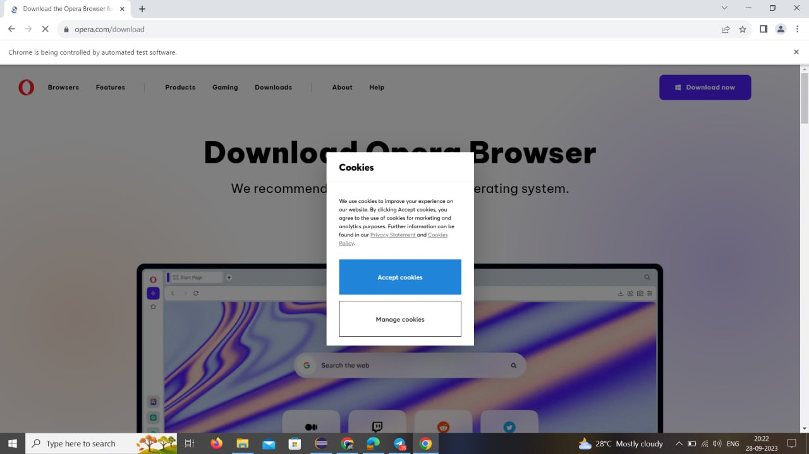Output :

